Name: Truong Dang Truc Lam  
ID: B2111933   
Class: CT209H-M04

**LAB 4**

**Web server and File Services**

**EXERCISE 0: CONFIGURE CA**

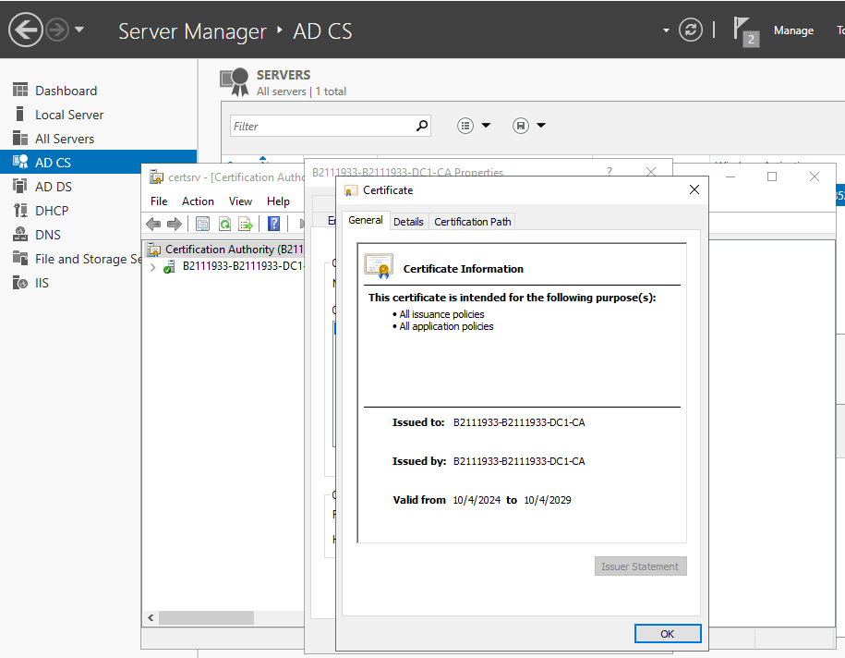

AD CS configuration

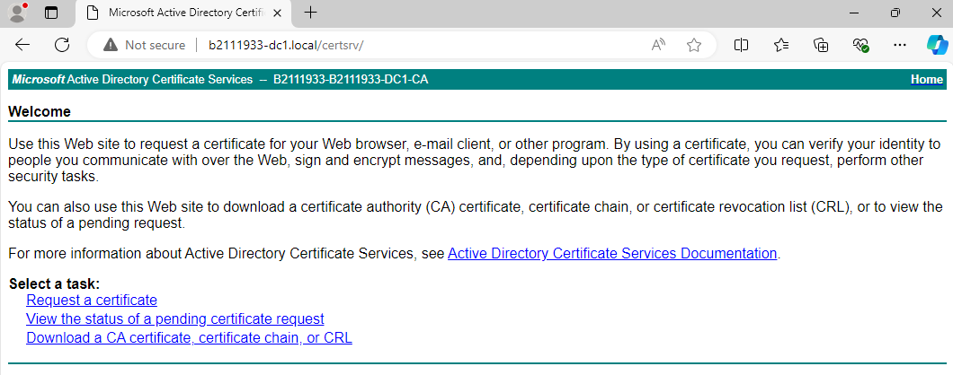

Connect from web browser

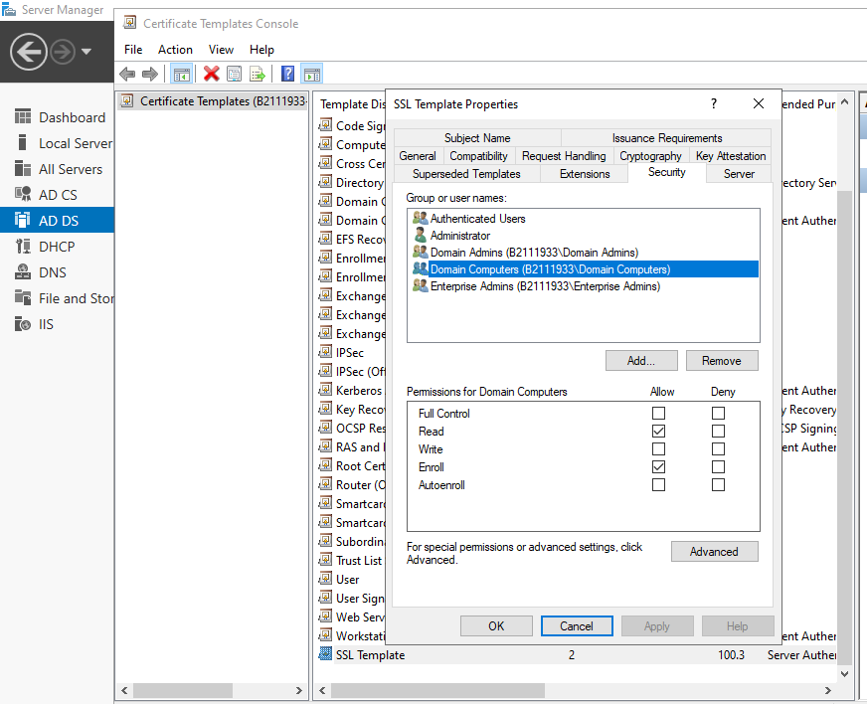

Create new template for SSL

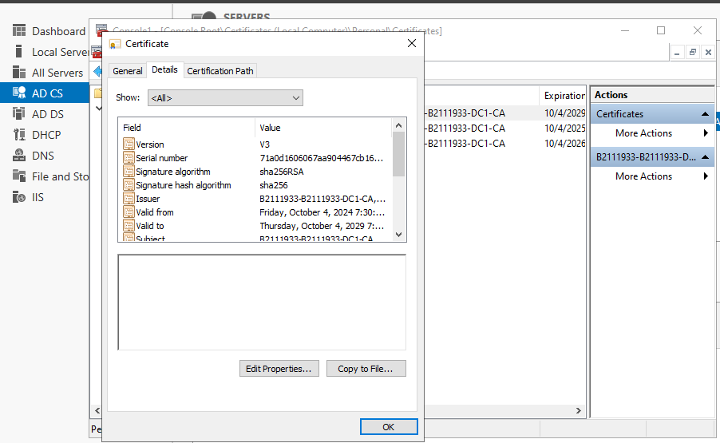

Request a cert from MMC

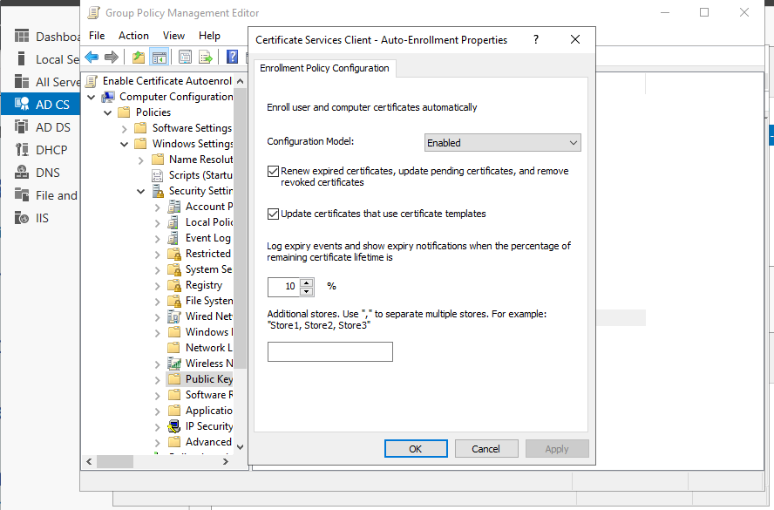

Create an autoenrollment policy

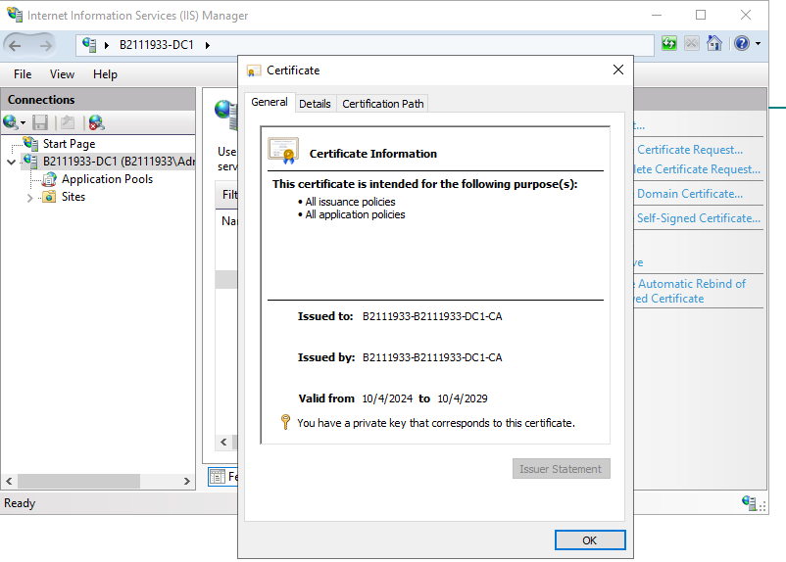

The key icon and the text indicates that SSL certificate works properly to protect the website.

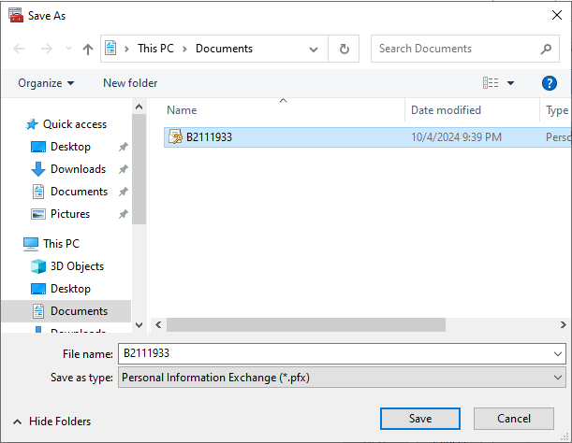

Export certificate

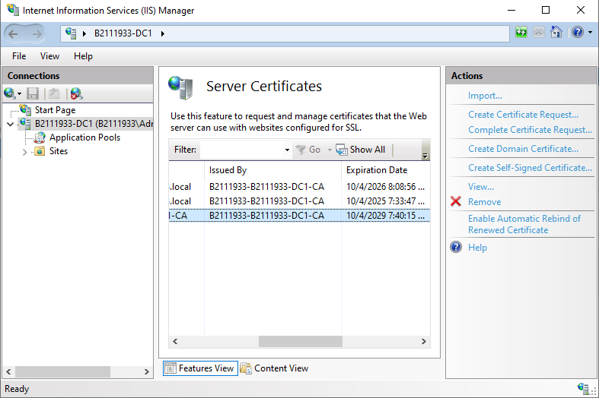

After import

**EXERCISE 1: INSTALL WEB SERVER**

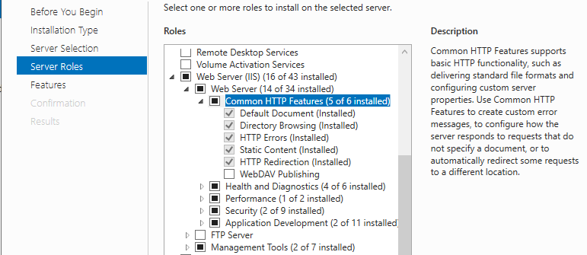

Install Web Server

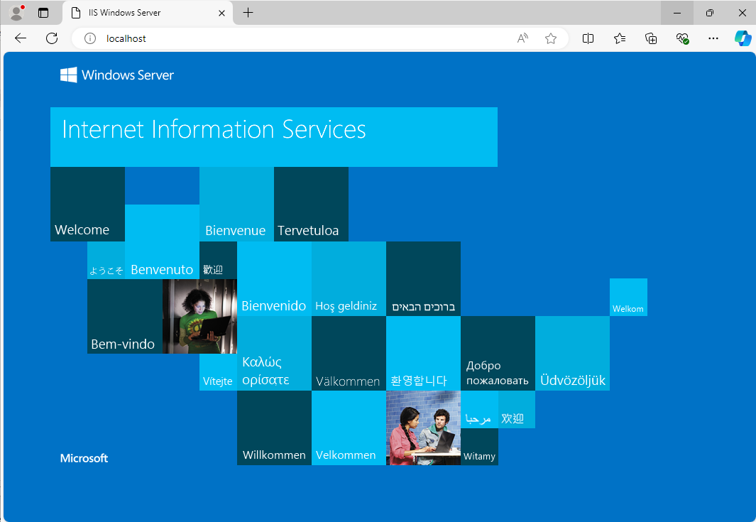

Verifying that Web server is working

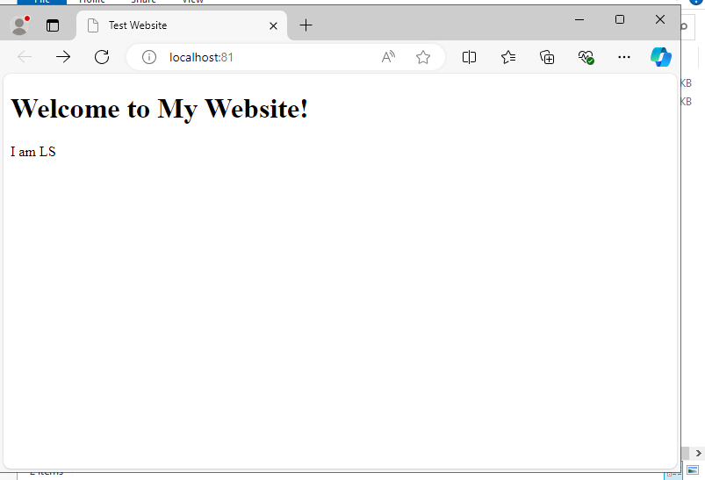

Launch my own website on port 81

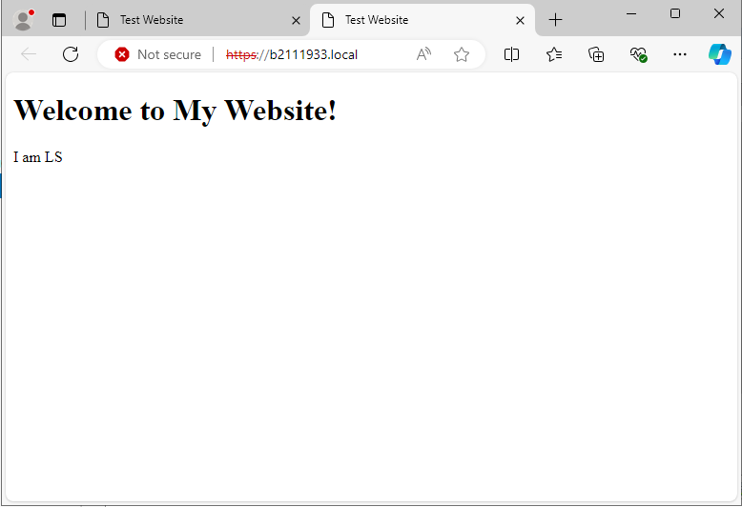

Configure Web server to run on HTTPS

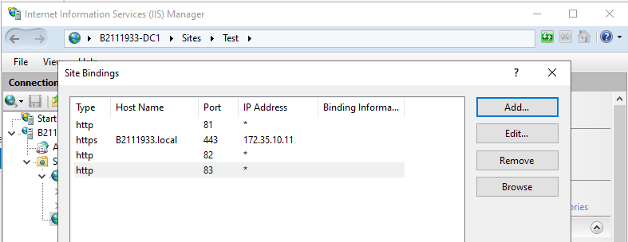

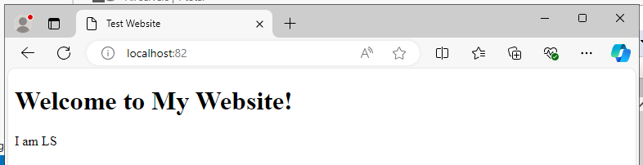

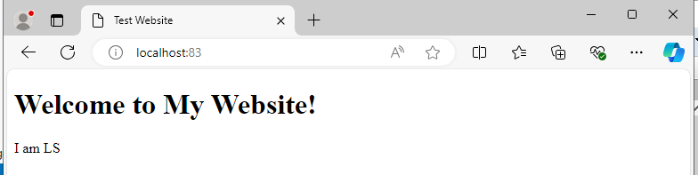

Hosting multiple websites with multiple ports

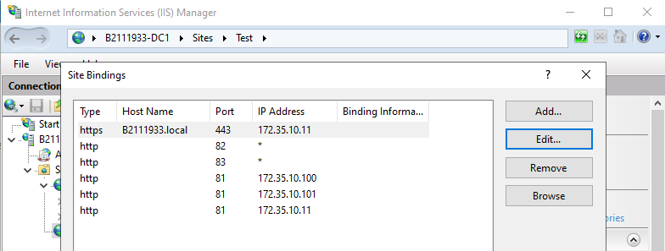

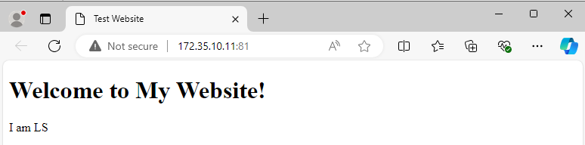

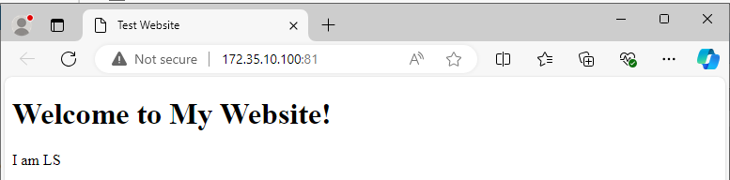

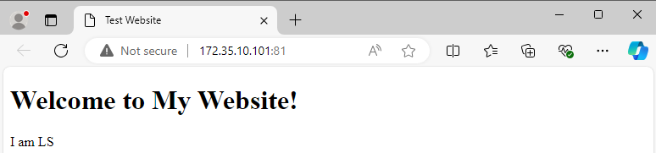

Hosting multiple websites with different IP addresses

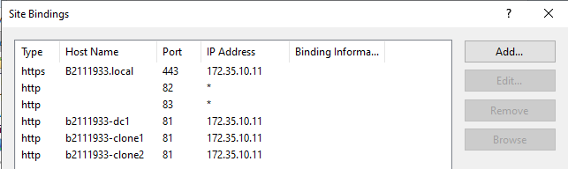

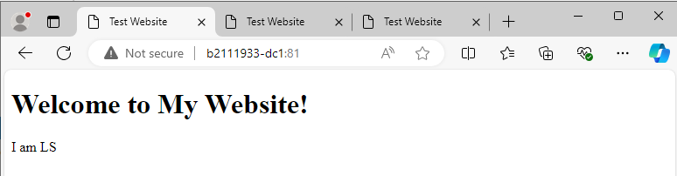

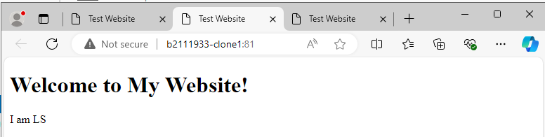

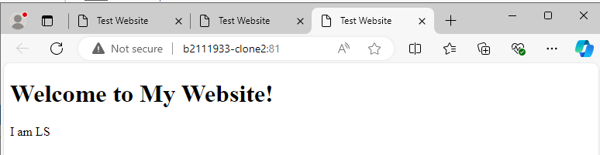

Hosting multiple websites with different host headers

**EXERCISE 2: INSTALL FTP SERVER**

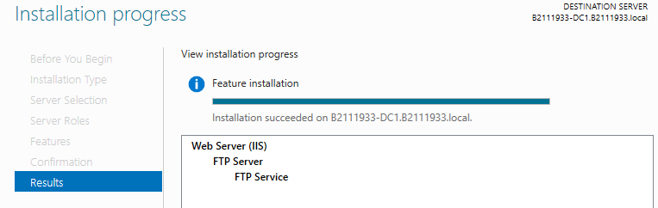

Install FTP Server

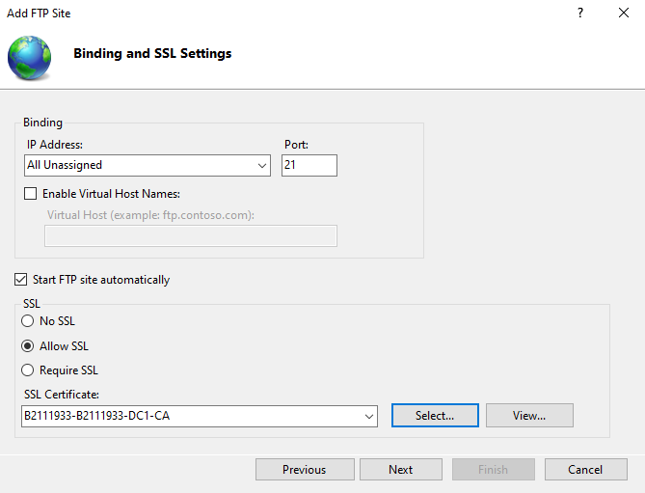

Configuring FTP server to use SSL

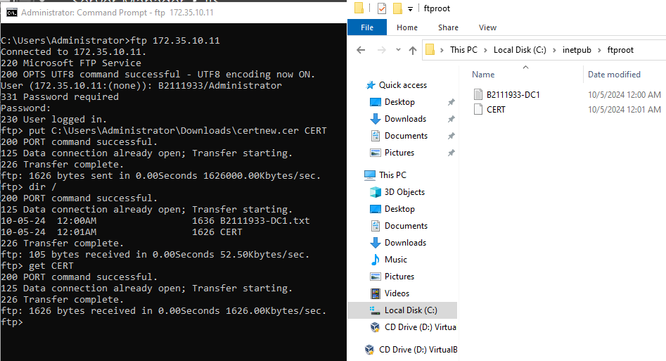

Verify that we can upload and download file from FTP Server with SSL

**EXERCISE 3: SHARING A FOLDER**

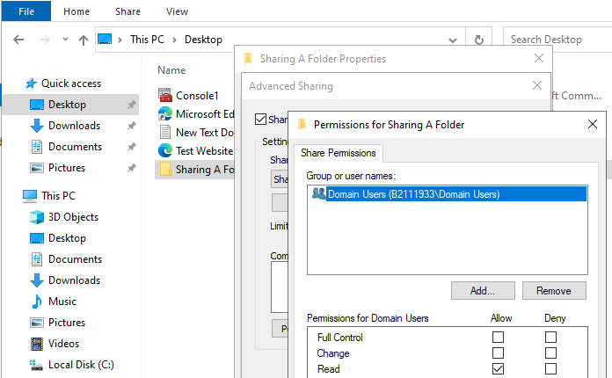

Sharing a folder

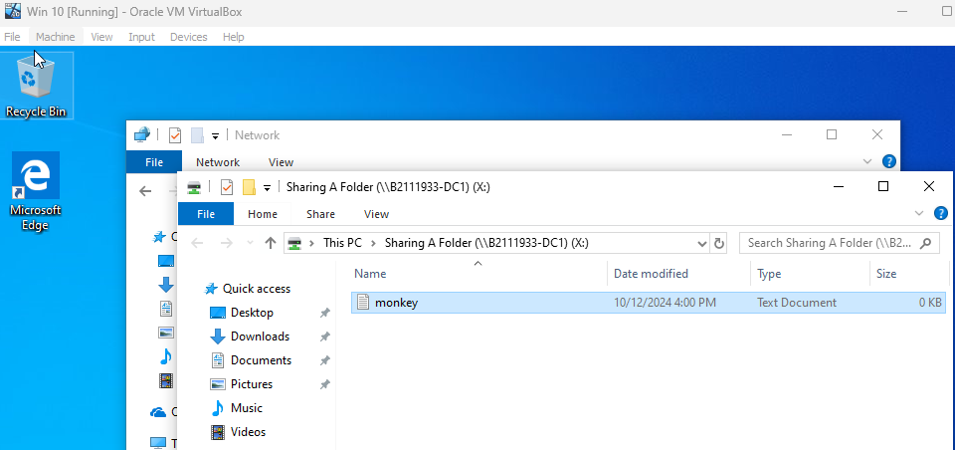

Connect from client and create a file

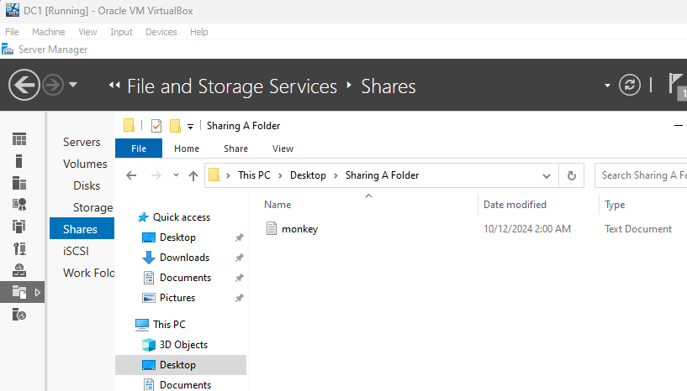

Check the result from DC1

**EXERCISE 4: CREATING SHARES WITH SERVER MANAGER**

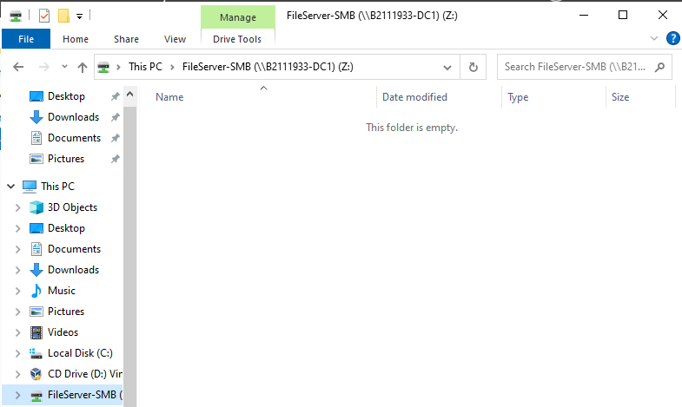

Create a new Share

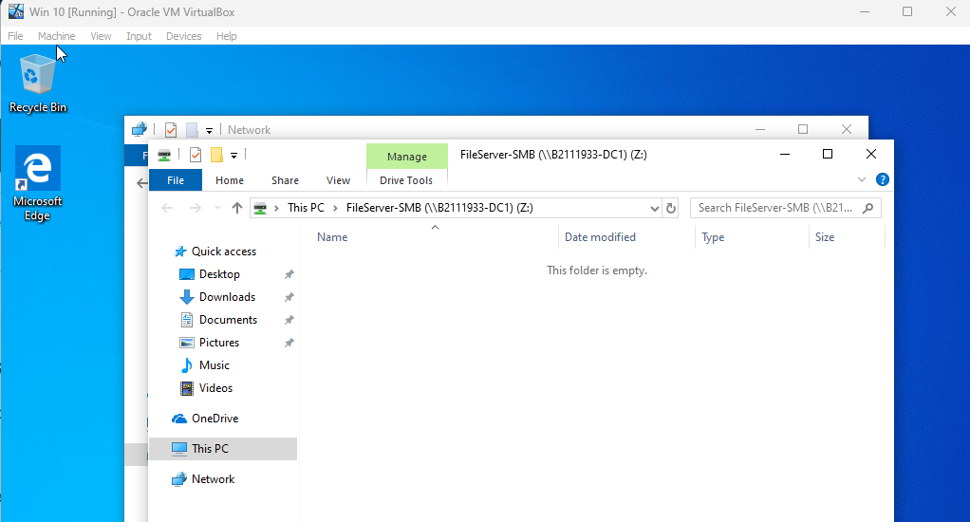

Connect to the Share

**EXERCISE 5: ENABLING DISTRIBUTED FILE SYSTEM AND CREATING A**

**NAMESPACE**

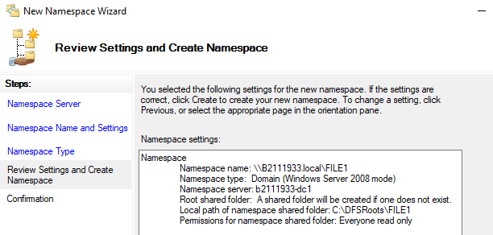

Create a Namespace

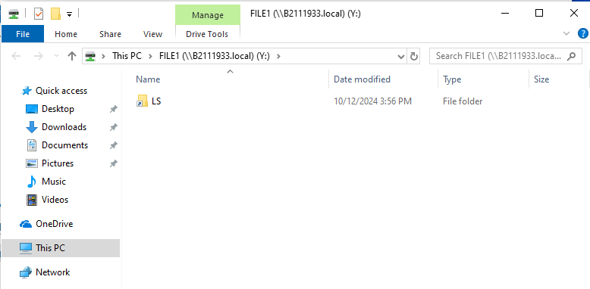

Connect to the Namespace

**EXERCISE 6: CONFIGURING DISTRIBUTED FILE SYSTEM REPLICATION**

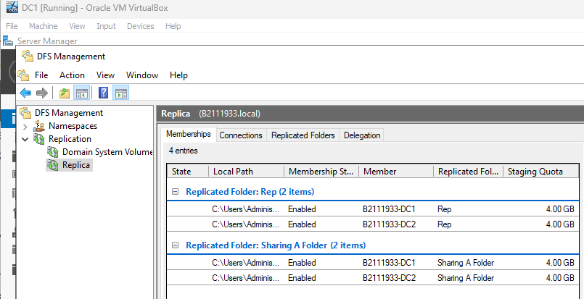

A file system replication

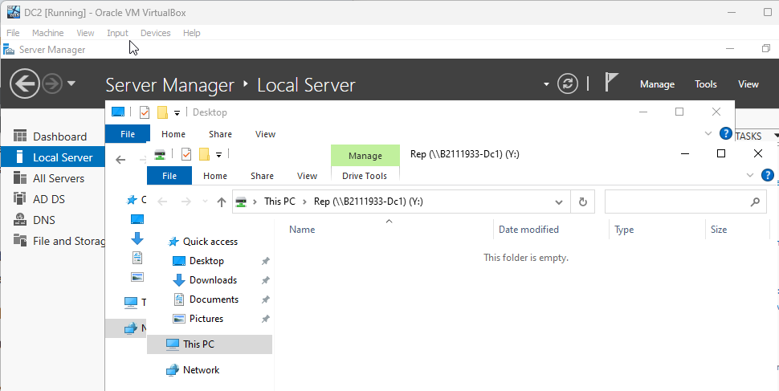

Connect to a file system replication

**EXERCISE 7: CREATING AN ISCSI TARGET ON YOUR SERVER**

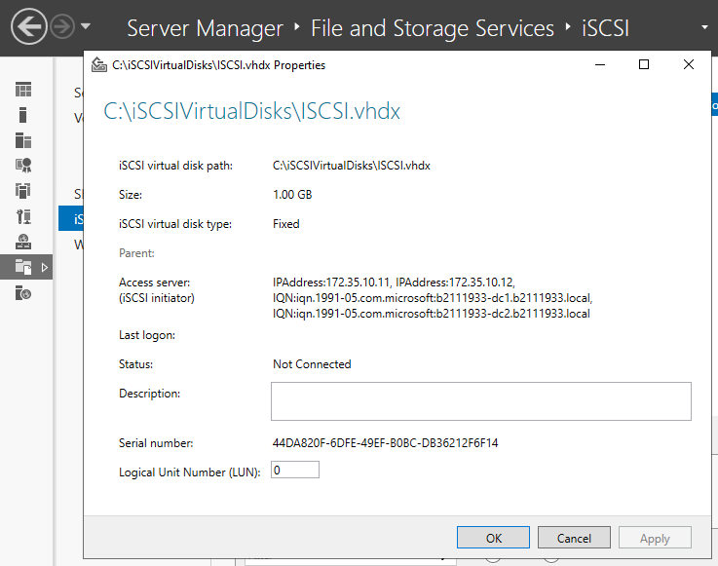

Create an ISCSI target

**EXERCISE 8: CONFIGURING AN ISCSI INITIATOR CONNECTION**

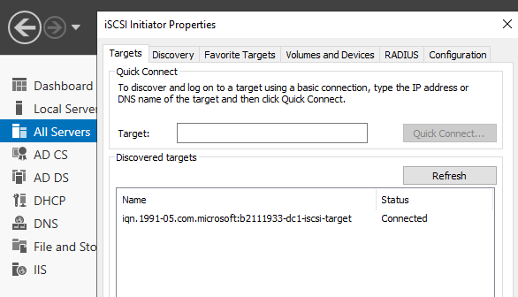

Configure an ISCSI initiator connection

**EXERCISE 9: SETTING UP WINDOWS SERVER 2019 WORK FOLDERS**

NFS